16. WRITE THE PYTHON PROGRAM TO IMPLEMENT BFS.
Aim
To write a Python program to implement the Breadth-First Search (BFS) algorithm to traverse a graph.
Algorithm
- Start the program.
- Create a graph using a dictionary.
- Select the starting node.
- Create an empty queue and add the starting node.
- Mark the starting node as visited.
- Remove the first node from the queue and display it.
- Add all its unvisited neighbouring nodes to the queue.
- Repeat steps 6 and 7 until the queue is empty.
- Stop the program.
Python Code

# BFS (Breadth-First Search)

from collections import deque

# Create a graph
graph = {
'A': ['B', 'C'],
'B': ['D', 'E'],
'C': ['F'],
'D': [],
'E': [],
'F': []
}

def bfs(graph, start):
visited = set()
queue = deque([start])
visited.add(start)

while queue:
node = queue.popleft()
print(node, end=" ")

for neighbour in graph[node]:
if neighbour not in visited:
visited.add(neighbour)
queue.append(neighbour)

# Start BFS from node A
print("BFS Traversal:")
bfs(graph, 'A')
Output:
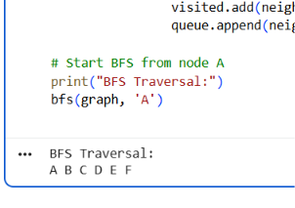
17. WRITE THE PYTHON PROGRAM TO IMPLEMENT DFS.
Aim
To write a Python program to implement Depth-First Search (DFS) to traverse a graph.
Algorithm
- Start the program.
- Create a graph using a dictionary.
- Select the starting node A.
- Mark the node as visited and display it.
- Visit an unvisited neighbouring node.
- Repeat until all reachable nodes are visited.
- Stop the program.
Python Code

# DFS (Depth-First Search)

graph = {
'A': ['B', 'C'],
'B': ['D', 'E'],
'C': ['F'],
'D': [],
'E': [],
'F': []
}

def dfs(node, visited):
if node not in visited:
visited.add(node)
print(node, end=" ")

for neighbour in graph[node]:
dfs(neighbour, visited)

print("DFS Traversal:")
dfs('A', set())
Output:
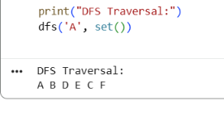
18. PYTHON PROGRAM TO IMPLEMENT TRAVELLING SALESMAN PROBLEM (TSP)
Aim
To write a Python program to find the minimum-distance tour for the Travelling Salesman Problem.
Algorithm
- Start the program.
- Define the distance between cities.
- Select the starting city A.
- Generate all possible orders of the remaining cities.
- Calculate the total distance of each tour, including the return to A.
- Select the tour with the minimum distance.
- Display the best tour and its distance.
- Stop the program.
Python Code

# Travelling Salesman Problem

from itertools import permutations

cities = ['A', 'B', 'C', 'D']

distance = [
[0, 10, 15, 20],
[10, 0, 35, 25],
[15, 35, 0, 30],
[20, 25, 30, 0]
]

start = 0
other_cities = [1, 2, 3]

min_distance = float('inf')
best_path = []

for path in permutations(other_cities):
tour = (start,) + path + (start,)
total = 0

for i in range(len(tour) - 1):
total += distance[tour[i]][tour[i + 1]]

if total < min_distance:
min_distance = total
best_path = tour

print("Best Tour:")
print(" -> ".join(cities[i] for i in best_path))
print("Minimum Distance:", min_distance)
Output:
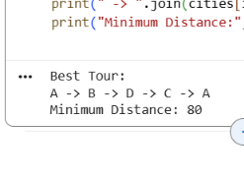

19. PYTHON PROGRAM TO IMPLEMENT A* ALGORITHM
Aim
To write a Python program to find the shortest path between a starting node and a goal node using the A* search algorithm.
Algorithm
- Start the program.
- Define the graph with distances between nodes.
- Define the heuristic values for each node.
- Select the starting node and goal node.
- Calculate \(f(n)=g(n)+h(n)\), where \(g(n)\) is the cost so far and \(h(n)\) is the estimated cost to the goal.
- Select the node with the lowest \(f(n)\) value.
- Repeat until the goal node is reached.
- Display the shortest path and its cost.
- Stop the program.
Python Code

# A* Search Algorithm

import heapq

graph = {
'A': {'B': 1, 'C': 3},
'B': {'D': 3, 'E': 5},
'C': {'D': 1},
'D': {'E': 2, 'G': 4},
'E': {'G': 1},
'G': {}
}

# Estimated distance to goal G
h = {
'A': 7,
'B': 6,
'C': 4,
'D': 3,
'E': 1,
'G': 0
}

def astar(start, goal):
queue = [(h[start], 0, start, [start])]
visited = set()

while queue:
f, cost, node, path = heapq.heappop(queue)

if node == goal:
return path, cost

if node in visited:
continue

visited.add(node)

for neighbour, distance in graph[node].items():
if neighbour not in visited:
new_cost = cost + distance
new_f = new_cost + h[neighbour]
heapq.heappush(
queue,
(new_f, new_cost, neighbour,
path + [neighbour])
)

return None, float('inf')

path, cost = astar('A', 'G')

print("Shortest Path:", " -> ".join(path))
print("Total Cost:", cost)
Output:
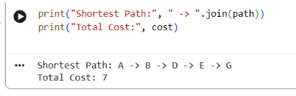
20. PYTHON PROGRAM FOR MAP COLORING USING CSP
Aim
To write a Python program to solve the Map Coloring problem using a Constraint Satisfaction Problem (CSP) approach.
Algorithm
- Start the program.
- Define the regions and their neighbouring regions.
- Define the available colors: Red, Green, and Blue.
- Assign a color to each region.
- Check that neighbouring regions do not have the same color.
- If a conflict occurs, try another color.
- Continue until all regions are colored.
- Display the color assigned to each region.
- Stop the program.
Python Code

# Map Coloring using CSP

regions = ['A', 'B', 'C', 'D']

colors = ['Red', 'Green', 'Blue']

# Neighbouring regions
neighbors = {
'A': ['B', 'C'],
'B': ['A', 'C', 'D'],
'C': ['A', 'B', 'D'],
'D': ['B', 'C']
}

assignment = {}

def is_safe(region, color):
for neighbour in neighbors[region]:
if assignment.get(neighbour) == color:
return False
return True

def solve(index):
if index == len(regions):
return True

region = regions[index]

for color in colors:
if is_safe(region, color):
assignment[region] = color

if solve(index + 1):
return True

del assignment[region]

return False

if solve(0):
print("Map Coloring Solution:")
for region in regions:
print(region, ":", assignment[region])
else:
print("No solution found")
Output:
